Enquiry Questionnaire
for
Hydraulic Starting Systems

{Title}

The information you provide in this document will help us recommend the most appropriate Hydraulic Start System for your engine.

May 2014

Engine Details
Basics | Engine make
 | Engine series
 | What is the engine driving? | Generator/Fire Water Pump/ Hydraulic Pump/ Other

Performance | No. of cylinders
 | Displacement | Litres
 | Power | kW
 | Firing Speed | RPM
 | No. of revolutions required for electronic engine | Rev

Break away torque | At +20°C
 | At 0°C | Nm
 | At -10°C | Nm
 | Firing Speed | Nm

Pinion Details

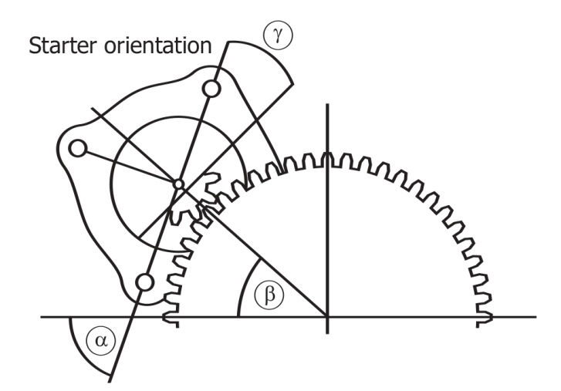
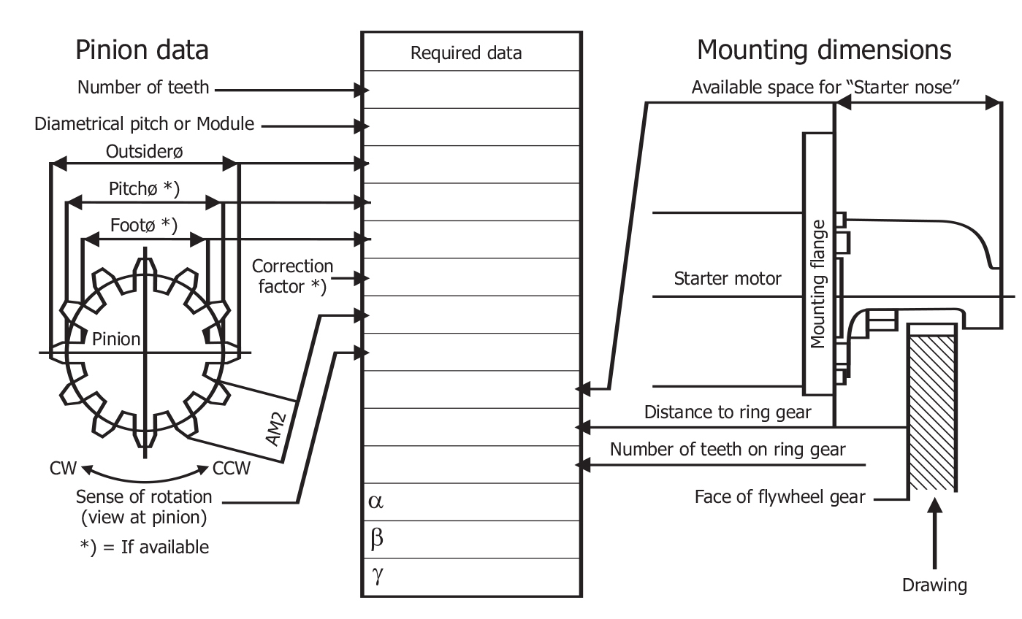
Mounting | Number of available starter mounting pads

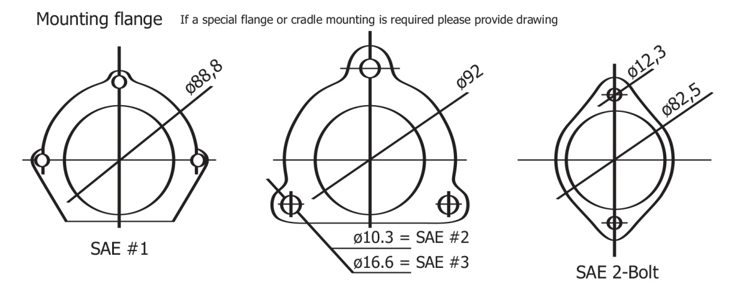

Flywheel Ring Gear | Tooth pressure angle | °
 | Tooth thickness | mm
 | Addendum
 | Whole depth | mm

Mounting Flange | Flange type (SAE)
 | Spigot diameter | mm
 | Centre of crankshaft to centre of starter mounting spigot hole | mm
 | Flange to leading edge of ring gear | mm

Site Details
Storage | Location | Offshore/Marine (indicate type of vessel)/Industrial
 | Minimum Temperature | °C
 | Maximum Temperature | °C
 | Humidity

Starting
Starts | Primary or secondary starting? | Primary/Secondary
 | How many consecutive starting attempts per fully charged accumulator are required?
 | Duration of each start in seconds per attempt?

Existing Start System
Existing system | Is the engine already fitted with an air starter? | Yes/No
 | If so, what is the make?
 | If so, what is the series?
 | IPU to supply air starter and associated accessories? | Yes/No

Initiation
Initiation | What type of initiation is required? | Foot start valve/Solenoid start valve/Cable start
 | Which type of recharge pump is required? | Electric motor (state available power supply)  Engine driven  Air driven (advise minimum guaranteed air pressure)  Mixture of above (state which)
 | Recharge time required

Note – all systems are fitted with a hand pump.

Controls
Controls | What types of controls/alarms are required? | Pressure switches / transmitters

Oil reservoir
Oil reservoir | What material is the oil reservoir? | Carbon steel (standard) / Stainless steel
 | Type of oil level gauge? | Upper and lower sight glasses / full length press to read / magnetic

Testing
Testing | Is a specific test certificate required for the air receiver? Such as LRS, ABS, ASME, please specify.

Installation
Installation | Is this installation in a safe or hazardous area? | Safe area / Hazardous area

Valves, manifolds and fittings
Valves and manifolds* | Parker (standard) | Yes / No
 | Swagelok | Yes / No
 | Other | Yes / No
*Applicable to air amplifier only
Tube fittings* | Swagelok (standard) | Yes / No
 | Parker | Yes / No
 | Other | Yes / No
*Applicable to air amplifier only

Hose Kit
Hose Kit | Is a hose kit required? If yes please indicate hose length in meters (up to 5 metres max.). | m

Painting Details
Painting | Finish colour
 | Paint specification

Installation Area
Installation Area | Width | mm
 | Length | mm
 | Height | mm

Shipping Details
Shipping | Shipping method

Notes
Every hydraulic start system is fitted with a manual pump regardless of any other charging system. On multi-bottle systems, the hand pump is used on test and commissioning for purging and priming purposes and can be used with care as a one directional barring tool. It is also an emergency pump in the event that no power is available to charge an accumulator.
The IPU standard build includes 100mm diameter stainless steel, full safety pattern pressure gauges with blow out backs. All instruments are mounted on stainless steel single block and bleed manifolds as standard.
Multi-bottle systems are supplied finished to IPU standard paint process.
Specification lead projects such as Petrobras, Technip, Shell, Exxon, etc. sometimes impose additional content, operating procedures, paint specifications, nominated vendors, etc. which always increase the system price.

